

Assignment

Topic 8 Puzzle Game Analysis And Solution Design
School Information & Electronic Engineering
Major Advanced Manufacturing and Informationization
Name Joshua Banda
Lecturer Professor PhD Ye lu
Finish Date 6 May 2018

May 2019

Abstract
N-puzzle problem has been one of the basic problem since the beginning of artificial intelligence. The most popular version of n-puzzle among people is 8- puzzle problem. It consists of an area divided into 3x3 grid containing 8 numbered (to identify) tiles and one empty grid. We are given an initial state and we have to reach the goal state which is also specified. In this project, we have used various informed search methods like a*algorithm, ida* algorithm to solve the puzzle. Various heuristic involved in the informed search like number of misplaced tiles, Manhattan distance were analyzed; Manhattan distance being one of the most popular ones. Drawbacks of the heuristics are mentioned and an improvement in Manhattan distance heuristic is implemente

Introduction
The Challenge faced was to break down the simple game of 8 puzzle and analyze it and break down a solution that a computer can explicitly follow with out being directly programmed to do so. And the most obvious solution was for the program to search possible moves from its initial move that would get it to the goal state. Though a number of searches where available the need for a faster more efficient model was presented and Thus the use of A star algorithm.

The problem.
The 8-puzzle problem is a puzzle invented and popularized by Noyes Palmer Chapman in the 1870s. It is played on a 3-by-3 grid with 8 square blocks labeled 1 through 8 and a blank square. Your goal is to rearrange the blocks so that they are in order. You are permitted to slide blocks horizontally or vertically into the blank square

Objectives
To solve the 8 puzzle using A star algorithm. Using Heuristics to overcome the challenges of selecting a node.

Constraints
Johnson & Story (1879) used a parityargument to show that half of the starting positions for the n-puzzle are impossible to resolve, no matter how many moves are made. This is done by considering a function of the tile configuration that is invariant under any valid move, and then using this to partition the space of all possible labeled states into two equivalence classes of reachable and unreachable states.

Methods
Various methods can be used to solve or approach the 8 puzzle game. Making use of a search algorithm to go through possible positions of the game board while at the same time abiding by the rules set by the game where no move can be made with out the Zero switching places with it.
A searching algorithm is used because the agent is capable of running through all possible nodes and it becomes a matter of finding the fastest route.

A star is used because of its performance and accuracy and ability to save on computational time by only visiting nodes it has to as opposed to other algorithms like breath first search or depth first search that will look at all possible nodes.

A* is an informed search algorithm, or a best-first search, meaning that it is formulated in terms of weighted graphs: starting from a specific starting node of a graph, it aims to find a path to the given goal node having the smallest cost (least distance travelled, shortest time, etc.). It does this by maintaining a tree of paths originating at the start node and extending those paths one edge at a time until its termination criterion is satisfied

What sets A star algorithm apart from other similar algorithms is its ability to make use of a Heuristic which is simply the theoretical distance from the current node to the goal node allowing it to always stay on track and only be searching nodes that bring it closer to the goal node thus allowing it faster performance.

Typical implementations of A* use a priority queue to perform the repeated selection of minimum (estimated) cost nodes to expand. This priority queue is known as the open set or fringe. At each step of the algorithm, the node with the lowest f(x) value is removed from the queue, the f and gvalues of its neighbors are updated accordingly, and these neighbors are added to the queue. The algorithm continues until a goal node has a lower f value than any node in the queue (or until the queue is empty).[a] The f value of the goal is then the cost of the shortest path, since h at the goal is zero in an admissible heuristic.

Implementation
The A star algorithm was implemented using Python programming language. There are two list maintained OPEN and CLOSED. This is to ensure a particular state does not get expanded more than once. CLOSED: contains already expanded nodes. OPEN: nodes on the frontier of the search tree. Initially CLOSED is blank and OPEN has only the start node.

The Heuristic is determined by counting the number of misplaced titles and their estimated number of moves from there current position to their goal position.

def calc_distance(node,goal,distance_travelled):
"""Calculation of huristic that is using manhantan distance to find
distance of misplaced tiles from there goal state location"""
h = 0
f = 0
x = 0
intial = node
for i in intial[0:len(intial)]:
y = 0
for j in i[0:len(i)]:
if(intial[x][y] != goal[x][y]):
loc1,loc2 = find_num(goal, intial[x][y])
if(loc1 == x):
h += abs(loc2-y)

elif(loc2 == y):
h += abs(loc1-x)

else:
h += abs(loc1-x)+abs(loc2-y)

y+=1
x+=1
return h+distance_travelled

Another important function of the algorithm would be the generation of neighbor nodes and this required the program to first locate the position of the 0 then generate possible neighbors as follows

def find_num(intial,num) :
"""Checks for the location of the zero to determine possible neighbors"""
x=0
for row in intial[0:len(intial)]:
y=0
for i in row[0:len(row)]:
if i == num:
return x,y
y+=1
x+=1

Next is the generation of neighbors:
def create_neighbors(intial_node):
"""Used to create all the possible children nodes of the parent nodes
by first locating the zero in the node then generating all the possible moves of the zero
based on the rules of the game"""
intial = intial_node[0]
x, y = find_num(intial,0)
neighbors = []
distance_travelled = intial_node[2] +1
a = np.array(intial)
b = np.array(intial)
c = np.array(intial)
d = np.array(intial)

if(x==0 and y==0):
a[x][y], a[x][y+1] = a[x][y+1], a[x][y]
c[x][y], c[x+1][y] = c[x+1][y], c[x][y]
neighbors.append(a)
neighbors.append(c)
return neighbors, distance_travelled

if(x==0 and y==1):
a[x][y], a[x][y+1] = a[x][y+1], a[x][y]
b[x][y], b[x][y-1] = b[x][y-1], b[x][y]
c[x][y], c[x+1][y] = c[x+1][y], c[x][y]
neighbors.append(a)
neighbors.append(b)
neighbors.append(c)
return neighbors, distance_travelled

if(x==0 and y==2):
b[x][y], b[x][y-1] = b[x][y-1], b[x][y]
c[x][y], c[x+1][y] = c[x+1][y], c[x][y]
neighbors.append(b)
neighbors.append(c)
return neighbors, distance_travelled

if(x==1 and y==0):
a[x][y], a[x][y+1] = a[x][y+1], a[x][y]
c[x][y], c[x+1][y] = c[x+1][y], c[x][y]
d[x][y], d[x-1][y] = d[x-1][y], d[x][y]
neighbors.append(a)
neighbors.append(c)
neighbors.append(d)
return neighbors, distance_travelled

if(x==1 and y==1):
a[x][y], a[x][y+1] = a[x][y+1], a[x][y]
b[x][y], b[x][y-1] = b[x][y-1], b[x][y]
c[x][y], c[x+1][y] = c[x+1][y], c[x][y]
d[x][y], d[x-1][y] = d[x-1][y], d[x][y]
neighbors.append(a)
neighbors.append(b)
neighbors.append(c)
neighbors.append(d)
return neighbors, distance_travelled

if(x==1 and y==2):
b[x][y], b[x][y-1] = b[x][y-1], b[x][y]
c[x][y], c[x+1][y] = c[x+1][y], c[x][y]
d[x][y], d[x-1][y] = d[x-1][y], d[x][y]
neighbors.append(b)
neighbors.append(c)
neighbors.append(d)
return neighbors, distance_travelled

if(x==2 and y==0):
a[x][y], a[x][y+1] = a[x][y+1], a[x][y]
d[x][y], d[x-1][y] = d[x-1][y], d[x][y]
neighbors.append(a)
neighbors.append(b)
neighbors.append(d)
return neighbors, distance_travelled

if(x==2 and y==1):
a[x][y], a[x][y+1] = a[x][y+1], a[x][y]
b[x][y], b[x][y-1] = b[x][y-1], b[x][y]
d[x][y], d[x-1][y] = d[x-1][y], d[x][y]
neighbors.append(a)
neighbors.append(b)
neighbors.append(d)
return neighbors, distance_travelled

if(x==2 and y==2):
b[x][y], b[x][y-1] = b[x][y-1], b[x][y]
d[x][y], d[x-1][y] = d[x-1][y], d[x][y]
neighbors.append(b)
neighbors.append(d)
return neighbors, distance_travelled

to maintain the open and closed list and give them functions such as push or append we make use of A class function:
class Node():
def __init__(self):
self.items = []

def view(self):
return len(self.items)

def pop(self): #deletes the last element added to queue
return self.items.pop()

def peek(self): #displays the last element added
if self:
return self.items[-1]

def push(self, item):
"""Add new node to list buy first checking """
if(len(self.items)>=1):
if(item[1]<=self.items[-1][1]):
self.items.append(item)
else:
temp = self.items[:]
self.items[:] = []
for i in range(len(temp)):
if(item[1]>temp[i][1]):
self.items.append(item)
for j in range(i,len(temp)):
self.items.append(temp[j])
break
self.items.append(temp[i])

else:
self.items.append(item)

def get_stack(self): #gets the whole queue listed from first in first out
return self.items

def is_empty(self): #checks if the queue is empty
return self.items == []

And finally the program is run from the start initialing the open and closed list and placing the initial state in the open list and the program simply runs while the open list is not empty. The program checks if the top element in the open list is the goal state if it is it the program returns success and stops running. If not it generates the possible moves of the node and adds the element to the closed list and the program keeps running until the goal state is reached.

while not open_list.is_empty():
intial_node = open_list.peek()
closed_list.push( open_list.pop())
if is_goal(goal_state, intial_node[0]):
print("Goal Found Hurray!!!\n\n")
print("Moves to win game = %d" % intial_node[2])
#n = []
#print(reconstruct_path(intial_node, n))
break
neighbors = []
neighbors,distance_travelled = create_neighbors(intial_node)
for i in range(len(neighbors)):
cost=calc_distance(neighbors[i],goal_state,distance_travelled)
chechnode = closed_list.get_stack()
w = True
for check in range(len(closed_list.get_stack())):
if(np.array_equal(chechnode[check][0],neighbors[i])):
w = False
if w:
open_list.push([neighbors[i],cost,distance_travelled,intial_node])
print(len(closed_list.get_stack()))

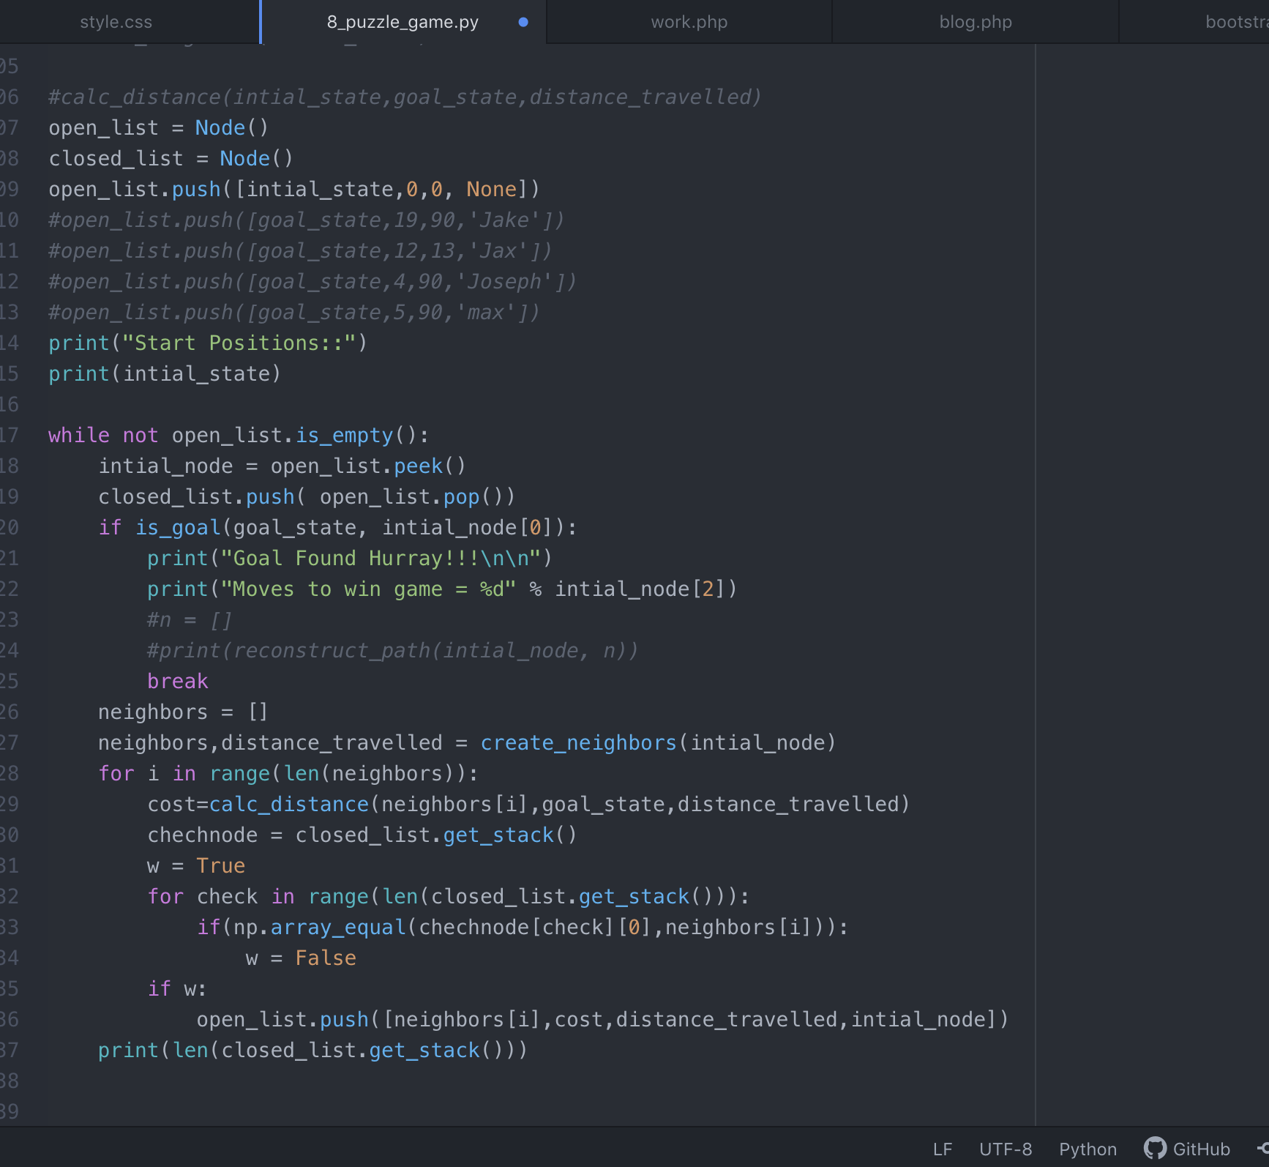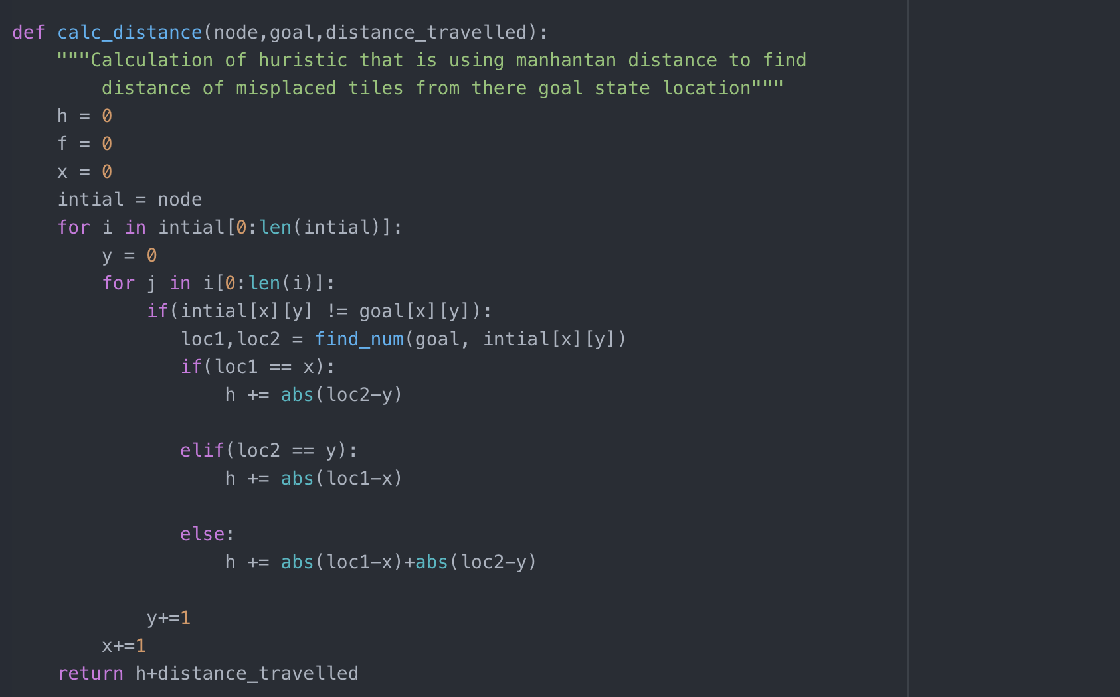

CODE TEST
The first test I did was on a simple set of movements that had only a few movements left to reach the goal state:

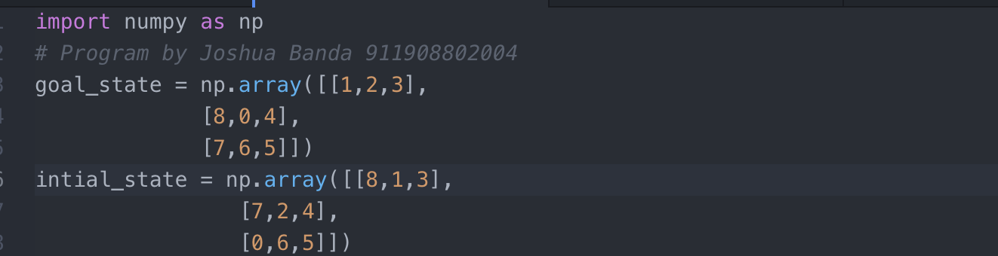

The test only had five tiles missed place so the test was faster with only four moves to get to goal state

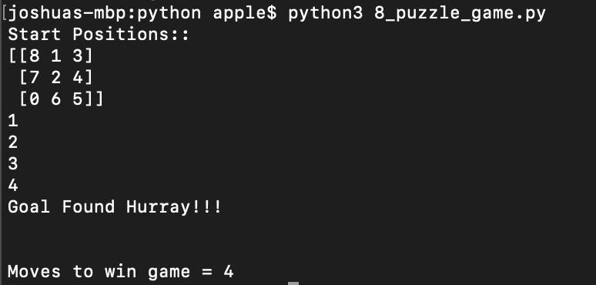

The second test had more tiles missed placed:

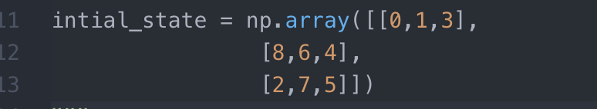

and the game visited 10 nodes before finding the goal state and it found that the shortest path from the initial to the goal state required 8 moves

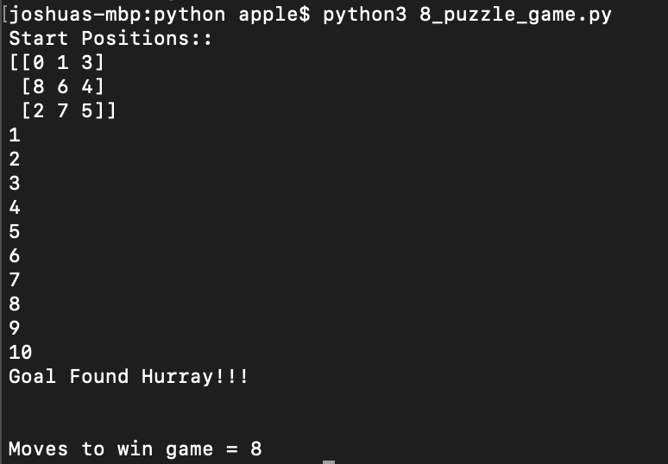

and the test from the initial state to goal toke 12 iterations:
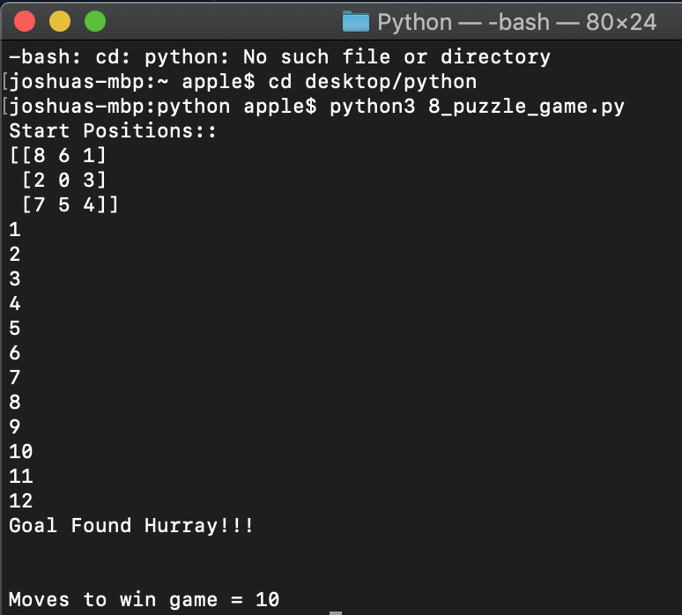

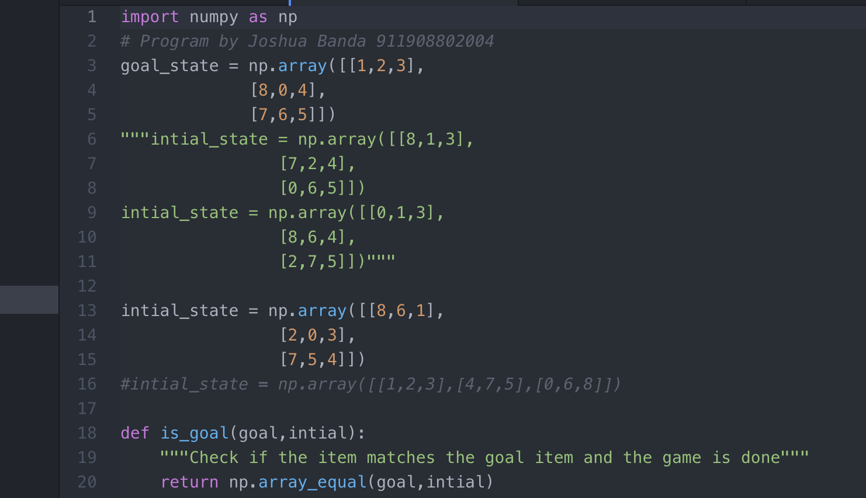

Conclusion
An approach for solving the 8-puzzle problem has been proposed which minimizes the memory required while achieving optimum results. All the heuristics have been applied to a* algorithm to bring uniformity and the results were shown. Comparison of memory used makes sense only in a star algorithm. At last memory use of all the heuristics are compared. Ida* algorithm was implemented but only with one heuristic i.e. number of misplaced tiles. A solvability check was implemented at the beginning of every program to avoid unnecessary run time errors and crashing of the program.

References
- Codeburst.” Algorithms I : Searching and Sorting algorithms” https://codeburst.io/algorithms-i-searching-and-sorting-algorithms-56497dbaef20
- Medium. “Algorithmic Trading in Crypto” https://medium.com/galois-capital/algorithmic-trading-in-crypto-430431da1e0a
- Wikipedia. “Search Algorithm” https://en.wikipedia.org/wiki/Search_algorithm
- Wikipedia. “Artificial Intelligence” https://en.wikipedia.org/wiki/Artificial_intelligence#Tools

- 8 Puzzle.com “Everything About Eight Puzzle” http://www.8puzzle.com
- National Institute of Technology Rourkela “Analysis and Implementation of Admissible Heuristics in 8 Puzzle Problem” http://ethesis.nitrkl.ac.in/5575/1/110CS0081-1.pdf

